IMPULSE PRORGRAMME – The European XR Accelerator
IMMERSIVE OPPORTUNITIES for Tech Ventures, Academics,
and Content Creators
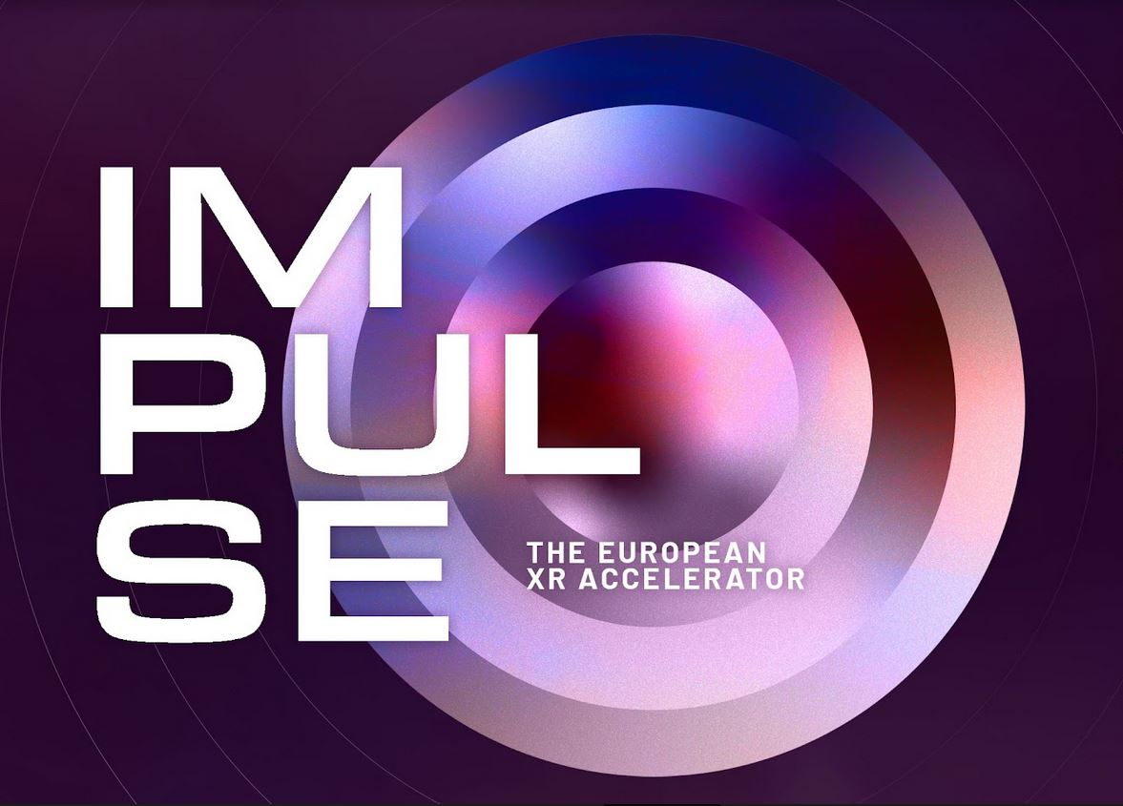
Laval, April 13, 2022 - Four big players of the European eXtended Reality (XR) scene – XR4EUROPE, LAVAL VIRTUAL, Stereopsia EUROPE, and VRDays Europe - team up to foster growth for entrepreneurs, creatives, and academics. By creating an environment for development and facilitating the matching of high-potential projects with their scaling counterpart. This new project, called the IMPULSE Programme, is launched this Wednesday during the LAVAL VIRTUAL conference, in front of a mixed crowd of eXtended Reality (XR) professionals and representatives from the private sector. It is dedicated to three verticals: Content, SMEs, and Research. For each one, there will be scouting, training, access to market, and nurturing phases involved in the Programme, for a holistic engagement with each selected project. Applications are now open for two verticals: Content and SMEs. Research will join in 2023.
Dedicated to facilitating meaningful connections for early-stage projects, the IMPULSE Programme is now seeking both applicants, and creative and commercial partners or investors to participate in its three phases:
First phase: All interested project holders have until 15 August to apply. Accepted projects will be notified 9 September after an evaluation and validation process by Stereopsia EUROPE & XR4EUROPE, alongside European experts.
Second phase: Project holders will receive coaching, grooming, and a confidence boost from industry mentors, before one-to-one pitching sessions organised for both Content & SMEs verticals at Stereopsia EUROPE (Brussels, 17-19 October). As outcome, only ten proposals per vertical will be selected for the next phase.
Third phase: The final pitch and meeting with investors will take place at VRDays Europe’s Immersive Tech Week (Rotterdam, 28 November - 2 December) for the ten selected projects of each vertical.

Those three phases will be followed by a fourth and ongoing, nurturing phase, to build and solidify the IMPULSE Community. The Programme will also feature lectures and networking meetups, mainly during all four partners’ events.
Throughout the IMPULSE Programme, attendees will increase their industry connections, their funding potential and further mature their individual projects. Content creators can thereby meet producers or distributors, and entrepreneurs be confronted to investors and venture capitalists.
General Information
The IMPULSE Programme is an amplifier of European reach: A unique, productivity-inducing, win-win situation for XR professionals and talents, industrials and investors wishing to develop their XR portfolio and knowledge, or integrate these technologies in their own companies, or provide reach and visibility to immersive artworks.
It aims to nurture the development of new European initiatives, targeting three verticals:
1/ Springboard for Storytellers
IMPULSE | CONTENT
Immersive narrative content creators encounter financiers, producers, and distributors.
2/ Finding the Next Unicorns
IMPULSE | SMEs
Matching tech startups and scaleups with investors.
3/ From Lab to Market (coming in 2023)
IMPULSE | RESEARCH
Connecting researchers with investors and entrepreneurs.

Applications & Info
The IMPULSE Programme – XR4EUROPE
Participation Fee: 300 € (+VAT) per person
- IMPULSE | CONTENT
- IMPULSE | SMEs

Contacts
XR4Europe – LB@virtualswitzerland.org
Stereopsia - alexandra@stereopsia.brussels
VRDays Europe - benjamin@vrdays.co

